GUVI TASK 15

1. Create aprivate s3 bucket

Enable block all public access option because this should not be accessible from outside.

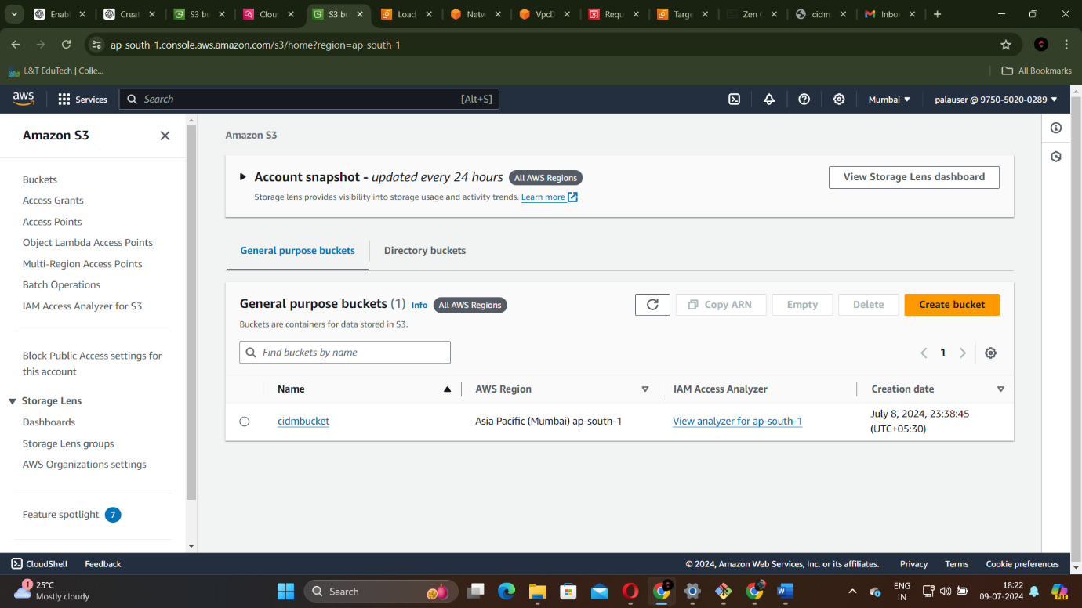

1. Upload files to the bucket.

You can upload any type of file for this bucket since this does not need static website.

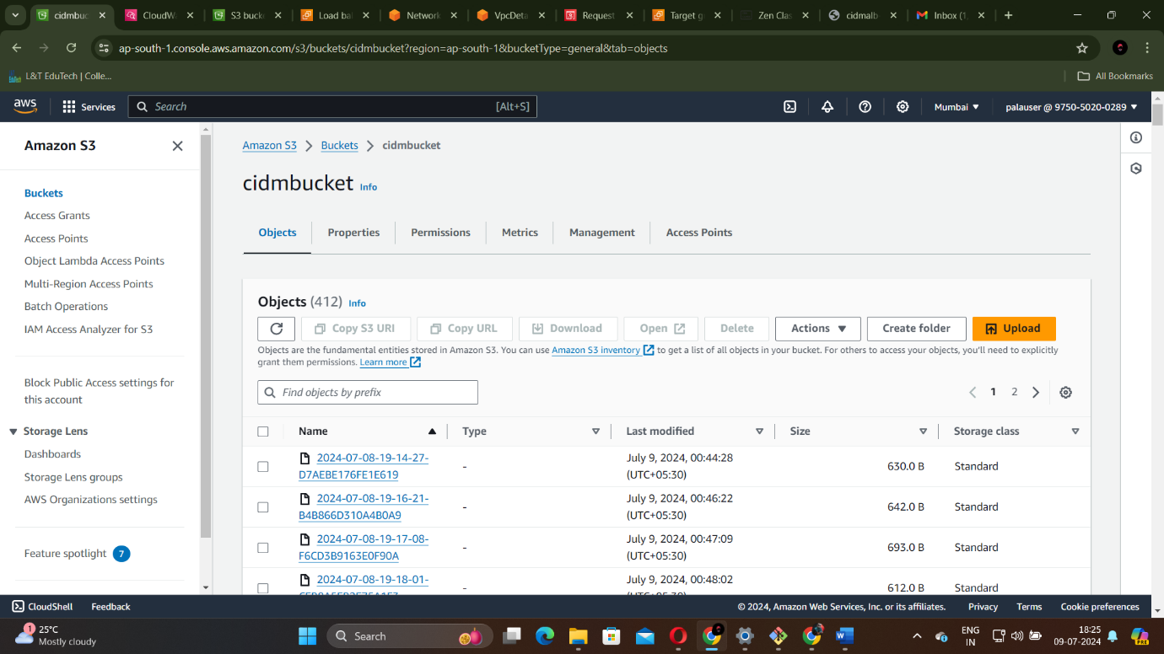

I have uploaded a txt file in this.

1. For viewing logs of your uploaded files enable server access logging when creating your s3 bucket. Also give a destination where your logs will be stored.

I have given the same bucket as logs destination.

1. Launch 2 ec2 instances. Use AMI as amazon linux, instance type as t2 micro, key pair any.

For network settings create a new security group which allows port 80.

Create a vpc for this task and add it as default vpc.

Create a subnet also in advance with a availability zone

Ensure a route table is attached to the vpc

Also create a internet gateway.

Now add that newly created security group and add it to the instance. create 2 instances finally.

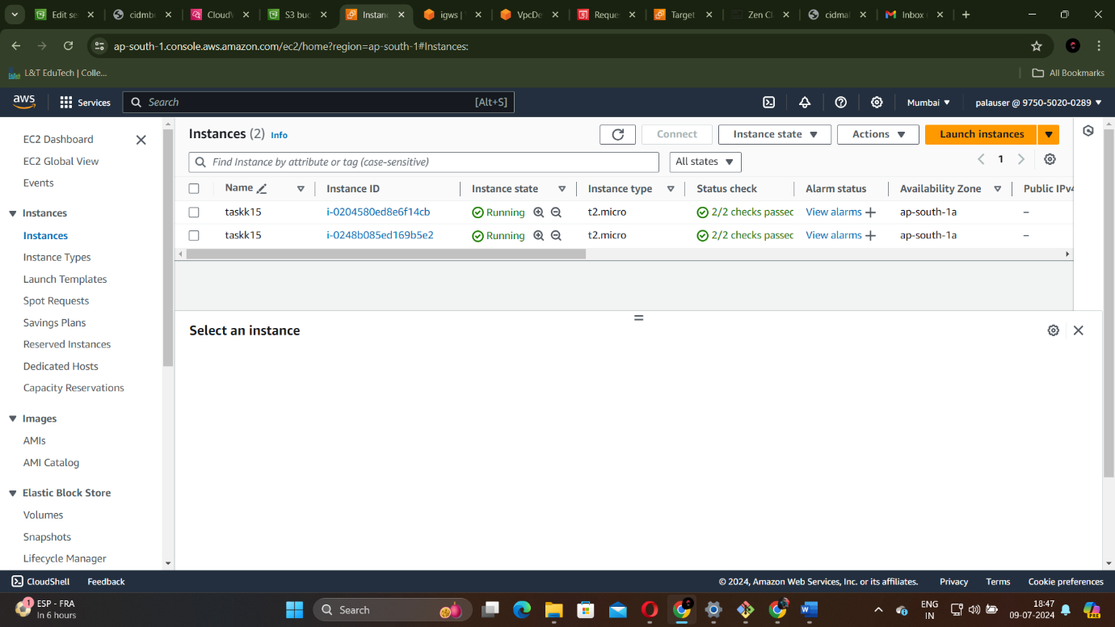

1. Ssh into 2 instances using any remote tool and install any web server.

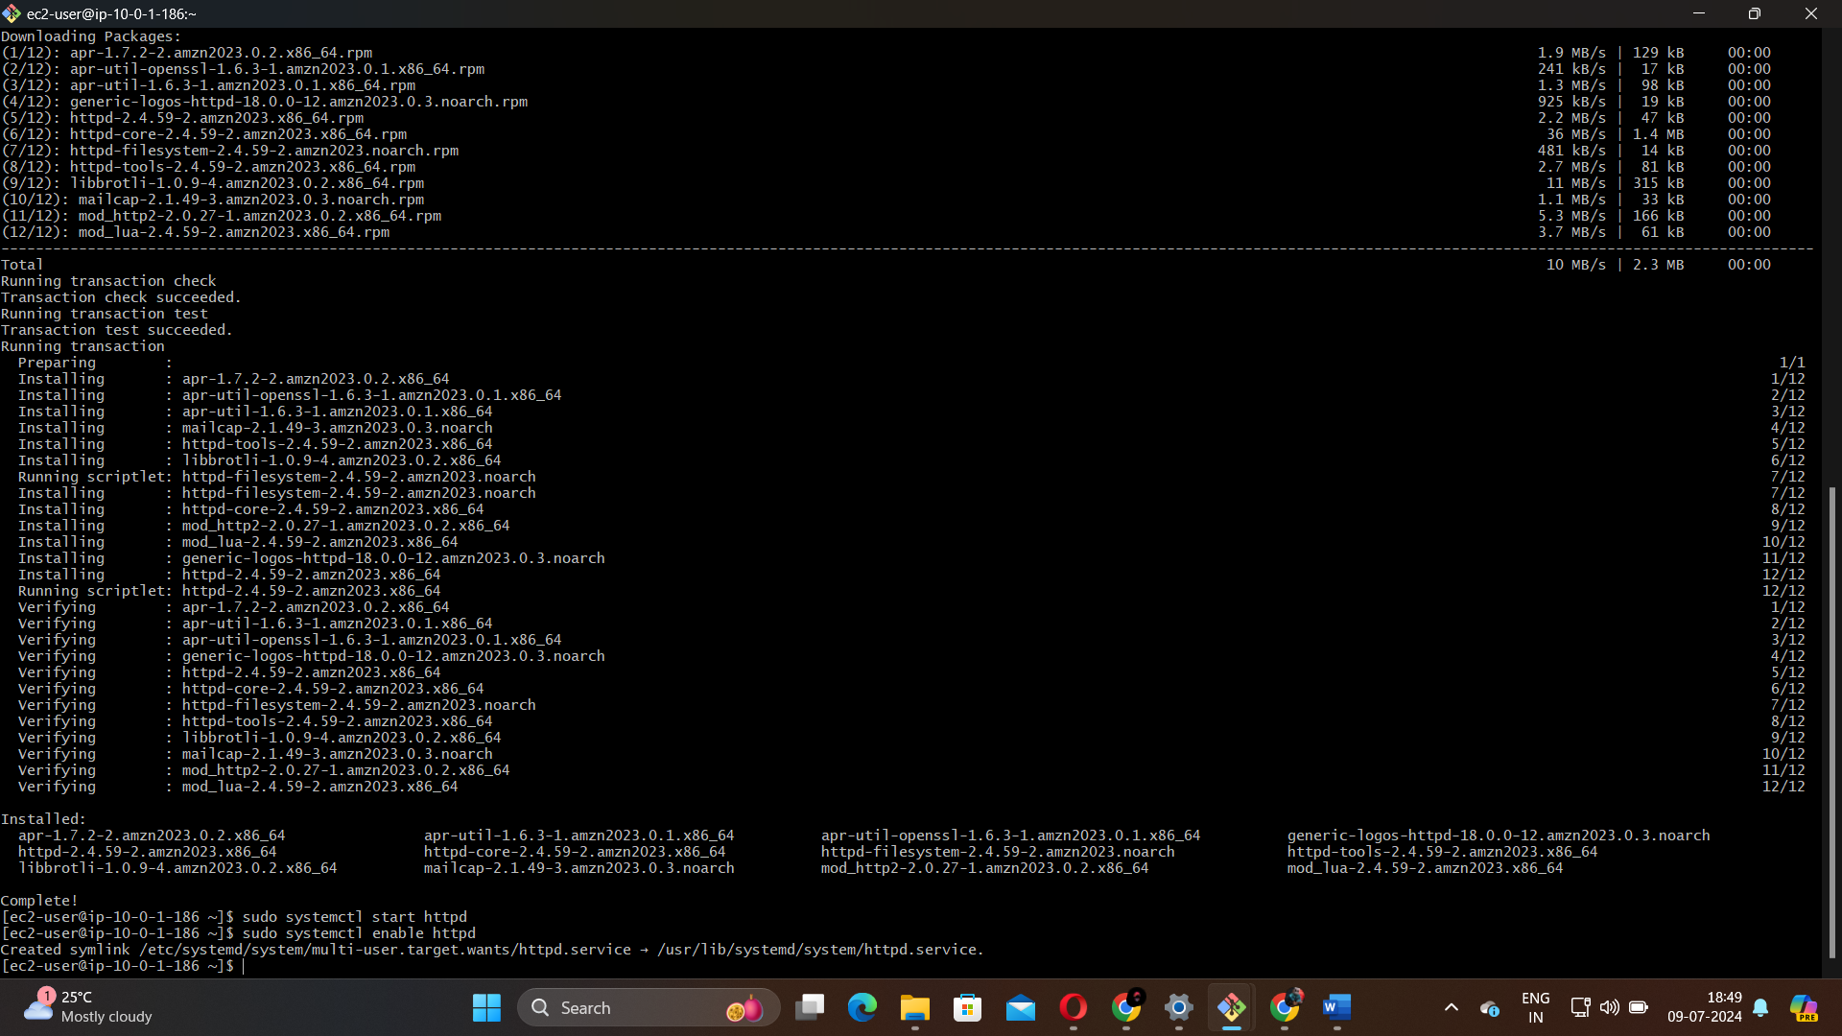

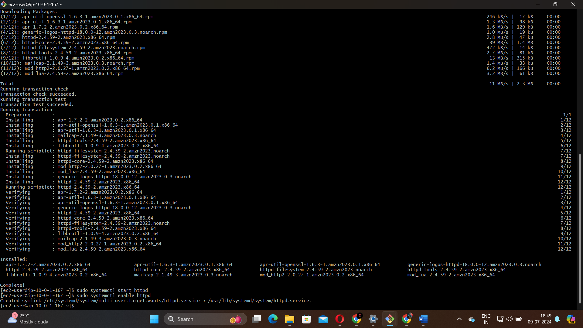

6.to connect ec2 instances with ALB you should register instances with alb. For that open load balancing select target groups. Select the target group you created for alb. Click on the target group. click edit and register your ec2 instances as targets.

7. to test the load balancer get the dns name of your alb from the description tab of your alb in ec2 console. Now copy paste the dns name in a web browser to verify the alb is distributing traffic to your ec2 instances.



-----X-----